INDIAN COUNCIL OF SOCIAL WELFARE
KERALA STATE BRANCH
Rajagiri College of Social Sciences
Rajagiri PO, Kalamassery, Cochin-683104
Ph.0484-2532654, 4111358
Email: icswkerala@gmail.com, Website: icswkerala.in

Annual Report 2018-19

Introduction

ICSW has been functioning in Kerala since 3rd October 1954. Kerala State branch has its office in the campus of Rajagiri College of social sciences Kalamassery, Ernakulam, with District branches in all the 14 districts of Kerala.

STATEL EVEL EXECUTIVE COMMITTEE FOR THE YEAR 2018-19
PRESIDENT : Dr.Mary Venus Joseph
Vice Presidents : Mr.Jacob Thumbayil Ernakulam
: Fr. Romance Antony Kollam
: Smt Rosakutty Abraham ,Idukki
: Jineshlal R V Thrissur
General Secretary : Ms Aisha Salim (28-7-2018 onwards)
Associate secretary : Mr. Shinto Varghese
Treasurer : Mr. Santhosh M

Immediate Past President : M.P.Antoni, Ernakulam

Immediate Past Gen Secretary : Mr. Deepak G, Ernakulam

Representative from Patron Members : V.J.Papoo, Ernakulam

Representative from Life Members : Ms. Neethu Elsa Alexander, Ernakulam

Representative from VO/NGO members : Fr.Varghese Kokadan, Ernakulam

Representative from Institutional member : Dr. J. Prasanth Palakkapillil CMI, Ernakulam

Representative from ordinary members : Mr.Unni Krishnan, Kottayam

Representative from State Branch
of Associations of Social Work : Dr.Rajeev S.P, Ernakulam

Co-opted members : Dr. Celine Sunny

; Ms.Beena Sebastian ,Ernakulam

: Dr. Cherian. P. Kurien, Idukki
: Dr.Anitha A, Ernakulam
: Kiran Thampi, Ernakulam
Life Membership
During year April 2018 –March 2019, the following are the 34 life members registered.
- Ben Mathew
- Varghese KT
- Neethu Renju
- Pulari Kurian
- Sreejith Nair
- Athira Unnithan
- Adithya Kumar
- Sachu M
- Ajith Tom George
- Renjith Manuel
- Dipin Raj
- Jasmine Mathew
- Bincy C C
- Rishika Rose
- Roopa .S
- Nikhil Raju
- Abdul Latheef
- Anitta Jacob
- Mathew Joseph
- Lal Babu
- Rony George
- Dimple Joseph
- Teenu Tellence
- Rex Mohan
- Swapna Rajan
- Gunavardhanan
- Nithiya Sebastian
- Paul Raj
- Bibin Gopi
- Jino james
- Abhilash Thomas
- Jacob Thomas
- Shylaja Rajendran
- Sulu Kusum Baiju

MEETINGS HELD / PARTICIPATED

State Executive Committee meeting
State Executive committee meeting was held on 7th July 2018. Main decisions taken were
- Renewal of the registration of ICSW Kerala for the year
- Initial efforts taken for the development and deployment of a new website for ICSW
- National affiliation fee for four years (2014-15, 15-16, 16-17, and 17-18) remitted at Central Office
- Audited the Accounts for the year 2014-15, 15-16, and 16-17 with the help of Accounts division- Rajagiri College.
- Felicitation of Mr. M P Antoni, the past President for his three decadal contribution to ICSW Kerala and for his present position as the member of the Kerala Commission for the protection of the right of the Child.
- ICSW State Office got an independent office space and was shifted to second floor in the same building.

Bank Account transfer
ICSW Kerala’s Bank Account was with the SBT Kalamassery branch, but with the merging of SBT to SBI, account was automatically to SBI Pathadipalam. On informing the new branch of change in signatory for the bank transactions it was not possible to start a savings account as per the SBI rules.

Annual general body meeting
The annual general body meeting of ICSW Kerala was held on Saturday 28th July 2018 at 10.am.
Mr. Anoop Joseph Joy made the welcome speech. Dr. Mary Joseph in her presidential speech told about the origin of ICSW in India and formation of ICSW Kerala branch. She also spoke about the strengthening of all district branches.
Mr. Anoop Joseph Joy presented the actions taken on the previous AGM meeting
Dr. Mary Joseph made a PowerPoint presentation of the highlights of the constitution of ICSW Kerala.
DR. Mary joseph president said that, the General Secretary, Mr. Anoop Joseph Joy was unable to continue as Secretary, as he was pursuing his Doctoral programme, there is a need for new secretary for ICSW Kerala. So existing Joint Secretary Mrs. Aisha Salim was elected as new General Secretary and Shinto Varghese as new Joint Secretary which was approved by general body members.
ICSW’s new website
ICSW’s new website is icswkerala.in.
Domain name has been purchased and website of ICSW Kerala state branch has started functioning. R LABZ was carried out the work.
Mr. Amal of R LABZ presented the new website to the members.

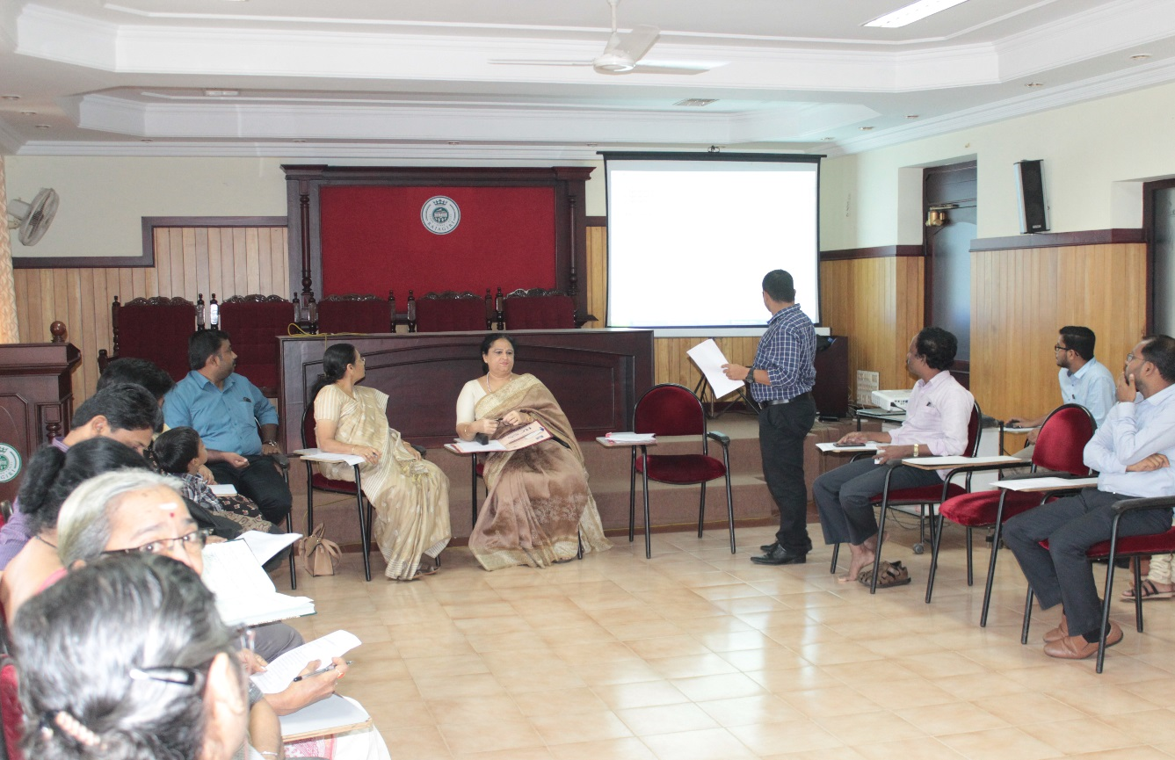

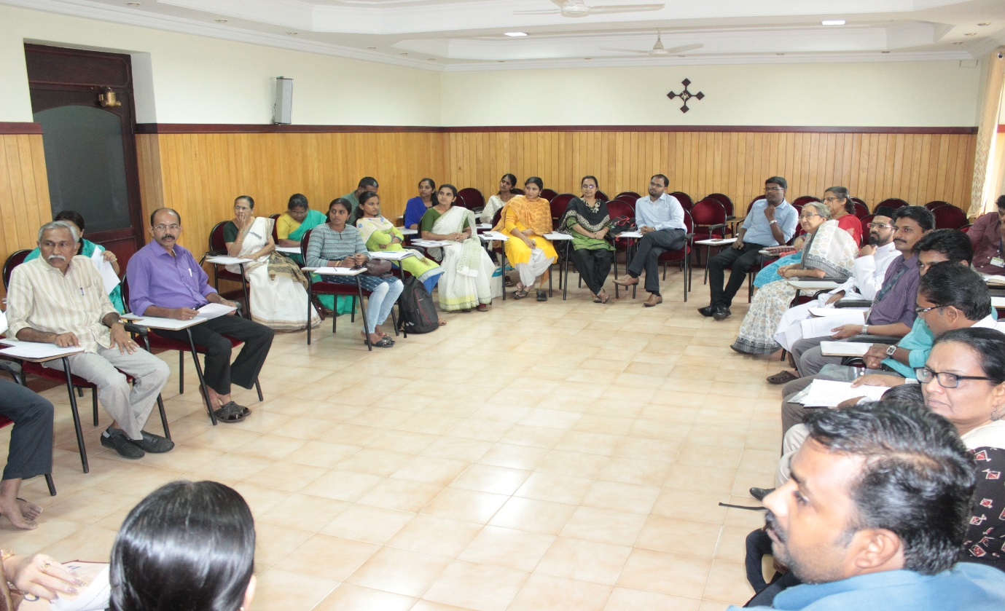

The following working Committee members were approved for the period 2018-19
Dr.Mary Venus Joseph : President
Smt. Rosakutty Abraham : Vice President
Mr. Jineshlal R V : Vice president
Mr. Jaob Thumbayil : Vice President
Fr. Romance Antony : vice president
Mrs. Aisha Salim : General Secretary
Mr. Shinto Varghese : Joint Secretary
Mr. Santhosh M : Treasurer

State Executive committee meeting
Thursday, 15th November, 2018
Ms. Aisha Salim read out the minutes of last meeting held on 7th July, 2018. Members gave approval for the same.
Account of ICSW has transferred from Pathadipalam to SBI South Kalamassery branch situated at Rajagiri Building . Bank authorities (SBI, SOUTH KALAMASSERY) suggested opening another non personalised savings account.
Dr. Mary joseph suggested that photos of the districts activities and events have to be displayed in the website. The names of the members must be displayed in the website.

Renewal of Registration of ICSW
ICSW Kerala State chapter has renewed up to March-2018. It was carried out at Malappuram from the year 2012 to 2018.
National Executive Committee Meeting
National executive Committee of ICSW held on Saturday 15th December 2018 at 11am at Madras School of Social Work, Chennai
Dr .Mary Joseph, our President-ICSW Kerala (Vice president, South Zone) attended the Meeting.

Verification certificates to ICSW life members employed outside the country
Verification certificates were issued to our life members during the year 2018-2019, who were working at different agencies in Middle East and European Countries. Their names are,
- Antony Augustine
- Varghese Esow
- Sebastian Thomas
- Jacob TC
- Greeshma Swaminadhan
- Jino James
- Swapna Rajan
- PaulRaj
Special Meeting for planning future programme
A special meeting was organised by DR. Mary Joseph on 28th March 2019 at 3. Pm, in order to plan a two day workshop for NGO members. Mr. Anoop Joseph Joy, Acting secretary and Ms. Shylaja- Administrative staff attended the meeting.
1.DR. Mary Joseph suggested that workshop for NGO’s should be residential and the topics may be learning organisation, sustainability, management etc. the programme is scheduled tentatively May 9th and 10th 2019.
17 SDGs
Sangamam
Valavi Award

It was also decided to conduct an orientation programme about ICSW in the Campus Community.

