Minutes of ICSW Kerala State Branch Executive Committee Meeting.
Date: Friday 12th April, 2018
Venue: Rajagiri College of Social Sciences
Time: 4 pm to 5.30 pm.
Members Present:
Dr. Mary Venus Joseph- President ICSW Kerala
Fr. Romance Antony -Vice - President, ICSW – Kerala
Fr. Prasanth Palakkappillil –Executive member
Jose Thayyil – President, Kasargod Branch
Mr. Ipe Varghese- Secretary, Kottayam Branch
Mr. Shinto Varghese- Joint Secretary ICSW – Kerala
Mr. Anoop Joseph Joy - Immediate Past General Secretary
Fr. Varghese Kokkadan–Executive member
Dr. Kiran Thampi –Executive member
Dr. Rajeev SP- Executive member
Apologies for absence were received from the following:
Ms. Aisha Salim : General Secretary, ICSW – Kerala
Mr. Jacob Thumpayil : Vice - President, ICSW – Kerala
Mr. Jineshlal R V : Vice - President, ICSW – Kerala
Dr. Rosakutty Abraham : Vice - President, ICSW – Kerala
Dr. Mary John : President, Trivandrum Branch
Mr. Firoz Khan : President, Malappuram Branch
Mr. Sunny Asariparambil : President, Kannur Branch
Mr. Deepak G : Executive member
Ms Anitha Arumugan : Executive member

Agenda no.1
The meeting started at 04.00 pm with a silent prayer
Agenda no.2
Dr. Mary Venus Joseph, President, ICSW Kerala paid homage to former ICSW National General Secretary Prof. K N George who have passed away. Members present observed one minute silence. She also shared some memories when she attended the National meeting held on 15th December, 2018 at Chennai.
Agenda no.3
Shinto Varghese, Joint Secretary, ICSW Kerala extended a warm welcome to all the members, followed by a self-introduction by the Executive Members.
Agenda no.4
In the absence of General Secretary, Joint Secretary Mr. Shinto Varghese presented the minutes of Executive Committee meeting held on 15 th Nov 2018. The Executive members unanimously approved the minutes.
Agenda no.5
Dr. Mary joseph presented the Annual Report for the year 2018-2019 with the help of a Power Point presentation. She spoke about the Registration Renewal of ICSW Kerala .She then spoke about the new website www. icsw kerala.in .She said eventhough the website has been launched it requires certain modifications. She also said that the Affiliation fee for past four years has been paid. She said that in the year 2018-19, 34 new life members enrolled into ICSW Kerala. She added that many members from overseas require verification certificate from ICSW Kerala. She also mentioned about Valavi Award. Valavi award was given after the name of John P Valavi, first state General Secretary, and his son Mr. Jose Valavi volunteered for contributing the same.
Agenda no.6
In the absence of Treasurer, Dr. Mary Joseph presented unaudited account statement for the year 2018-2019 .She said that only income ICSW Kerala is receiving is from the life membership. The committee suggested that ICSW Kerala has to strengthen its institutional membership.
Agenda no.7
Then there was a discussion about Amendment of the Constitution. All the members stated that all the present memberships may be continued. Fr. Prasanth Palakapilly stated that amount for membership may be enhanced accordingly. He added that ICSW Kerala has not able to increase subscription as of now because ICSW Kerala is not an active body. According to him Institutional Membership could only be increased when ICSW Kerala becomes more active.
With regard to Good Standing Certificate Fr. Prasanth Palakapilly said that ICSW Kerala could collect a fee for it . But according to him before issuing it there should be some criteria for the issuing of the certificate. Dr. Mary Venus Joseph suggested that for issuing the same they can associate with our District chapters.
Agenda no.8
The committee engaged in a long discussion about the activities that have to be organized for the year 2019-2020.
Dr. Mary Venus Joseph, President, Icsw Kerala said that icsw kerala should primarily focus on NGO’s

She suggested for a capacity building workshop for the NGO’s .She enquired who will be the beneficiaries’ for the same.
Dr. Ipe Vargheese, Executive member said that many organization closed down as per Juvenile Justice Act so ICSW Kerala should get involved in this matter.
Dr. Rajeev SP, Executive member stated that certain organisations maintained the standard which allow them to continue their operation as per Juvenile Justice Act
Fr. Romance Antony, Vice President Icsw Kerala said that ICSW Kerala should take over NGO welfare issues. He added that District level gathering of NGO’s should be carried out. He said in Kollam District it would be organised in the month of June.
Dr. Ipe Vargheese said that Partners Meet of NGO’s who are associated with BCM College Kottayam in field work of students will be carried out. He added that ASSK is providing membership for 5000 /- for Schools of Social Work so ICSW Kerala should focus more on NGOs.
Jose Thayyil , Kasargod Executive member ensured that ICSW Kerala would be strengthened in Kasaragod District.
According to Fr. Prasanth Palakapill ICSW Kerala should provide unique things to NGO’s like may be Sustainable Development Goals or can focus on HCL like funding. He added that ICSW Kerala could focus on small programmes like awareness against the use of plastic.
Fr. Varghese Kokkadan stated that ICSW Kerala could take up two or three themes while organizing programmes. He said that his organization (CEVA) would take up two clusters in Kerala.
Dr. Kiran Thampi, Executive member said that ICSW Kerala should first of all decide the area that it is going to focus when associating with NGO’s and said that there are ten dimensions that ICSW Kerala could focus on. He continued by saying that Ngo’s should carry out a self-evaluation as there is no common evaluation at present for NGOs, so as no accreditation of grading for NGOs. As of now Kerala Voluntary Policy of 2007 governs NGOs operations in Kerala.
Even though there are 31 lakh NGOs in India only thirty to fourty thousand NGOs are registered with NGO Darpan a site for registering NGOs . In Kerala around 3.76 lakh NGOs are there. Out of which only 10% conforms to the necessary standards.
Fr. Romance Antony said that parallel accreditation may be carried out through ICSW Kerala for NGOs .
Dr. Mary Venus Joseph considered whether that can be made as a bench mark?
Executive Members pondered whether ICSW Kerala has been registered under NGO Darpan. It was stated that as of now it has not been registered.
Dr. Ipe Vargheese said that even Residents Associations could be focused by ICSW Kerala inorder to strengthen the chapter.
Fr. Prasanth Palakapilly stated that ICSW Kerala was really a strong chapter in India .He said that of the late the chapter was becoming weak so he requested the members to have new insight for strengthening the chapter. He added that ICSW is an organization that is well recognized by international organizations like UNICEF and UNESCO.
He told that international news letter of ICSW could be included in ICSW Kerala website.
Dr. Mary Venus Joseph stated that people from different professions like Doctors, Lawyers, and Engineers should be brought to the fold of ICSW Kerala so as to strengthen the organization.
Agenda no.9
Dr. Mary Venus Joseph presented the resignation letter of General Secretary Mrs. Aisha Salim before the executive committee and said that due to her family commitments she had to resign.
Dr. Mary Venus Joseph proposed the name of Anoop Joseph Joy as the new functional General Secretary till the next Annual General Body Meeting. The members present unanimously approved the suggestion.

Agenda no.10
Dr. Mary Venus Joseph proposed the budget for the Year April,2019-March,2020. The members present unanimously approved the proposed budget.
Agenda no.11
Anoop joy read out an adoption case of 2012, before the members for their suggestion. Fr. Prasanth Palakapilly said that it would be a better idea to consult with Mrs Meena kuruvilla or M P Antony for the same.

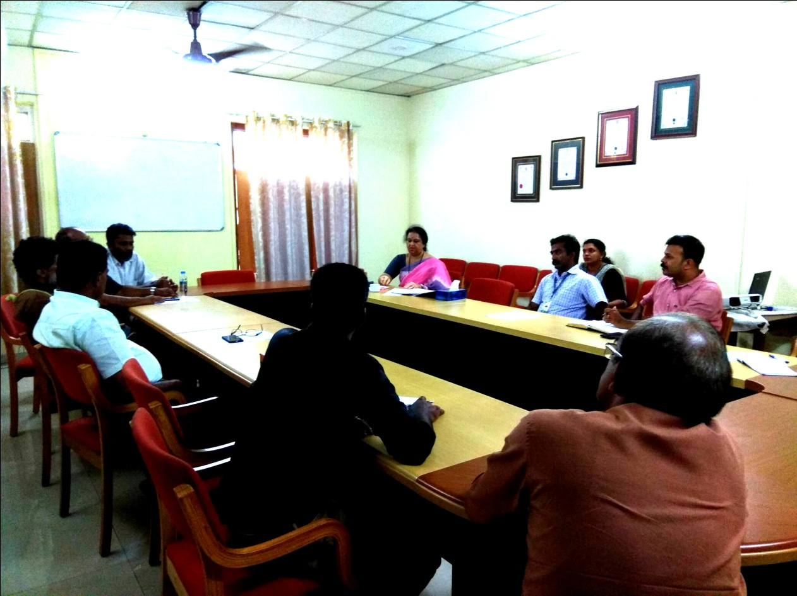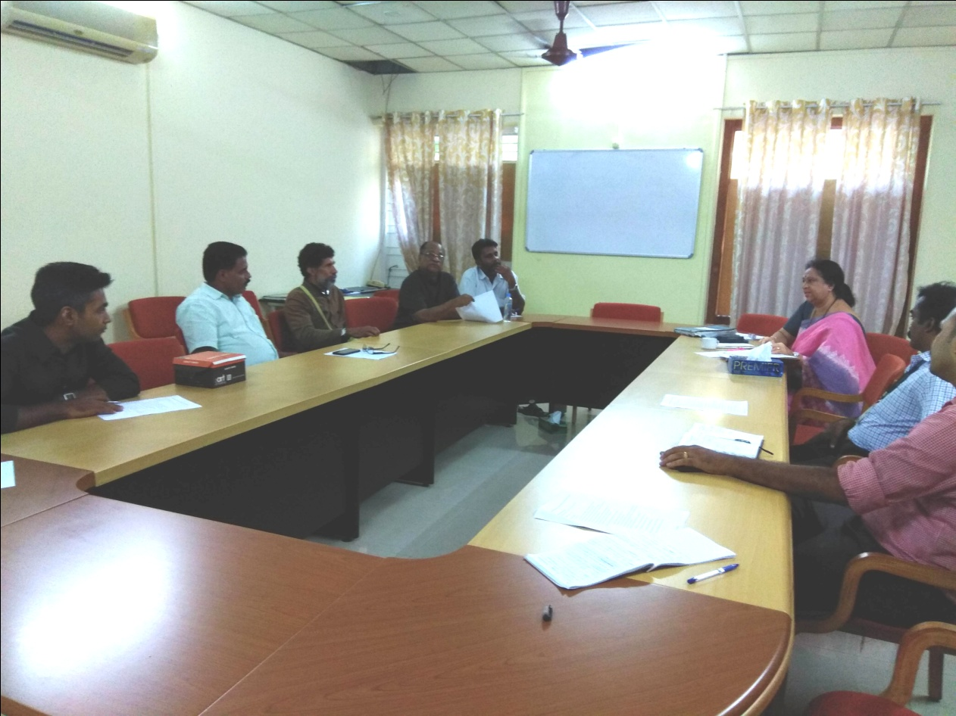

Agenda no.12
The meeting concluded at 5.30 pm with a vote of thanks by Anoop Joseph Joy , functional General Secretary ICSW- Kerala State Branch .

