Minutes of the Annual General Body Meeting of ICSW Kerala State Branch

Date: 29.07.2023
Venue: Rajagiri College of Social Sciences, Kalamassery, Kochi
Time: I1.00 am to 2.00 pm
Agenda

- Silent Prayer
- Welcome- Dr. Kiran Thampi, General Secretary, ICSW - Kerala.
- Presidential Address- Mr. M N Gunavardhanan IAS (Rtd), President, ICSW-Kerala.
- Confirmation of Minutes of the Annual General Body meeting held on 23rd March 2022.
- Review of action taken on the decision of the last AG meeting.
- Introducing the new members and welcoming them.
- Presentation of Annual Report 2022-23.
- Presentation of Audited Statement for the year 2022-23- Mr. Anoop Joseph Joy, Treasurer, ICSW Kerala
- Changes to the existing Bank Account
- Registration Renewal of ICSW Kerala for the year 2023-24
- Plan of Action with the budget for the year 2023-2024
- Election of ICSW Kerala office bearers 2023-2024
- Any other matter
- Vote of thanks
Members Present
- Mr. M N Gunavardhanan IAS (Rtd): President, ICSW Kerala
- Smt. Rosakutty Abraham: Vice President, ICSW Kerala (Idukki branch)
- Mr. Jose Puthukkadan: Vice President, ICSW Kerala (Thrissur branch)
- Dr. Kiran Thampi: General Secretary, ICSW Kerala
- Mr. Anoop Joseph Joy: Treasurer, ICSW Kerala
- Mr. Deepak G: Joint Secretary, ICSW Kerala
- Mr. Suresh P: District Chapter representative (Thrissur)
- Mr. Ranjith: District Chapter representative (Ernakulam)
- Mr. Aniyan Cherian: Immediate past General Secretary, ICSW
- Meena Kuruvilla: Life Member
- Sebin Thomas: Life Member
- CV Antony: Life Member
- Jasmine Mathew: Life Member
- Fr. Jolly John: Life Member
- Ashlin Mary Mathews
- Jona Joy
- Shilpa V Yohannan
- Rincy Joseph
- Shanty Babu
- Kesiya Saju
- Beena Sebastian: Life Member
- Rojin Roy
- Nycil Romis Thomas: Life Member
- Sr. Lins Rani CMC: Institutional Member
- Sr. Sophia Rose CMC: Institutional Member
- Sr. Jasmine: Institutional Member
- Dr. Anish K R: Life Member
- Jessymol K J: Office Assistant

Apologies for absence were received from the following:

- Fr. Romance Antony: Vice president ICSW Kerala
- Firoz Khan: Executive Member
- Dr. Mary Venus Joseph: Immediate past President, ICSW Kerala
- Mr. Sunny Asariparambil: Vice President, ICSW Kerala
- Mr. P C Jose: Executive Member
- P K Johny: Executive Member

Agenda item No. 1: Silent Prayer
The Annual General Body Meeting of the ICSW Kerala State Branch started at 11.00 a.m. with a silent prayer. Mr. M N Gunavardhanan IAS (Rtd), President, ICSW Kerala introduced him to all the members and shared his experience when he worked as the Social Welfare Director. Followed by a self-introduction by members.
Agenda item No. 2: Welcome
Dr.Kiran Thampi, General Secretary of ICSW-Kerala, made the welcome speech. He welcomed the president, Executive Committee members, State Council members, and all the members present at the meeting. He appreciated the honorable President of ICSW-Kerala, Mr. M N Gunavardhanan IAS (Rtd), for being elected as the National Vice President, ICSW and Smt. Roakutty Abhram for her effort to promote the membership campaigning in Idukki chapter.
Agenda item No. 3: Presidential Address
Mr. M N. Gunavardhanan, IAS (Rtd), made the Presidential address. He spoke about the impact of the media on social problems, mainly drug abuse. He explained the manner in which mafia tracks school-going children with regard to drug addiction and the importance of artificial intelligence. He also reminded the ICSW members that they should take the initiative to submit a comprehensive report to the Government and the Social Welfare department to ensure the proper working of the systems.
Agenda No. 4: Confirmation of Minutes of the Annual General Body meeting held on April 23th2022 at Rajagiri College of Social Sciences, Kalamassery campus, Kochi.
Dr.Kiran Thampi presented the Minutes of the previous Annual General Body Meeting held on April 23th2022. The Minutes of the previous AGM were unanimously approved by every member.
Agenda No. 5: Review of action taken on the decision of the last AG meeting.
Dr. Kiran Thmpi reviewed the action taken at the previous AGM held on April 23, 2022. He explained that the Renewal of the registration of the ICSW Kerala chapter for the year 2019–2022 had been completed. The SBI account of ICSW had been changed from Savings to current. Auditing of accounts for the year from April 1, 2022, to March 31, 2023, had been completed.
Agenda item No. 6: Introducing the new members and welcoming them
Mr. M N Gunavardhanan, IAS (Rtd), President, ICSW Kerala, welcomed the New Life Members of ICSW-Kerala. The new members were introduced in the meeting.
Agenda No. 7: Presentation of Annual Report for the year 2022-23
Dr. Kiran Thampi presented the annual report for the years 2022–23. He explained in detail the ICSW-Kerala meetings, seminars, and workshops conducted. The General Body members unanimously approved the Annual Report for the years 2022–23. Three Verification certificates for ICSW life members employed outside the country were issued during the period.

Agenda No. 8: Presentation of Audited Statement of Accounts for the year 2022-2023
Mr. Anoop Joseph Joy, Treasurer, presented the audited statements for the years 2022–23. The meeting discussed the audited receipts and payments account and the income and expenditure account in detail. At the end of the financial year 2022–23, there was a bank balance of Rs. 80,729 and cash in hand of Rs. 7,413. 31 new life members enrolled during the financial year. The General body members unanimously approved it and suggested to write off depreciating fixed assets while preparing the account statement for 2023-24.

Agenda No. 9: Changes to the existing Bank Account

Mr. Anoop Joseph Joy, Treasurer, informed about the Bank account changes from Savings to the Current SBI account. The General Body unanimously changed the verification fee from Rs. 250 to Rs. 2000 rs.
Agenda No. 10 Registration Renewal of lCSW Kerala for the year 2023-24
Dr. Kiran Thampi explained that the registration renewal for the years 2023–24 is to take place within a fortnight of the AGM.
Agenda item No. 11: Plan of Action with the budget for the year 2023-2024
Mr. M. N. Gunavardhanan, IAS (Rtd), President, ICSW Kerala, briefed on the Plan of action for the year 2023-2024 of ICSW Kerala. The main plans are to revive the membership drive in colleges and to conduct Sangamam-NGO meet.
Agenda item No. 12: Election of ICSW Kerala office bearers 2023-2024
Election of new office bearers of ICSW Kerala 2023-2024 was held. The working committee members elected for 2023-2024 which was approved by the General Body members are as follows.
- Mr.M N Gunavardhanan IAS (Rtd): President, ICSW Kerala
- Smt. Rosakutty Abraham: Vice President, ICSW Kerala (Idukki branch)
- Mr. Sunny Assariparambil: Vice President, ICSW Kerala (Kannur Branch)
- Mr. Jose Puthukkadan: Vice President, ICSW Kerala (Thrissur branch)
- Mr. P C Jose: Executive Member ICSW Kerala (Wayanad District Chapter)
- Dr. Kiran Thampi: General Secretary, ICSW Kerala
- Mr. Anoop Joseph Joy: Treasurer, ICSW Kerala
- Mr. Deepak G: Joint Secretary, ICSW Kerala
- Mr. C V Antony: Executive member

Agenda item No. 13: Any other matter
- Smt. Beena Sebastian suggested the ICSW Kerala can promote the membership drive in the Social Work colleges, including the Sociology college. She also stated that State office bearers need to directly participate in the dive and ICSW Kerala needs a full-time staff for the drive activities. Also, she states the utilisation of ICSSR funds through projects and the need to formulate an agenda to empower the NGOs, and she points out that the ICSW Kerala should focus on strengthening and supporting the NGOs and submitting the reports to the government.
- Adv. Sebin Thomas stated that the ICSW Kerala is a monitoring body for the NGOs, and provision to receive funds need to be checked. The body suggested checking the international bylaw for any provision to change the amendment.
- Mr. M N. Gunavardhanan, IAS (Rtd), told that the ICSW Kerala is only affiliated with the National body and not with the International body. He Proposed Mr. Suresh as the district coordinator to conduct the membership drive and informed that the ICSW will formulate a separate committee for the working of the membership drive.
- Fr. Jolly spoke about the need to start the ICSW Kerala committee in every college, including the HODs of the social work department, to conduct an easy drive like KAPS. Mr. Aniyan Cheriyan replied that the district chapters need to lead the drive like a nodal agency to avoid the duplication of the district Chapter.
- Dr. Anish K R stated that before starting the membership drive, the ICSW needed to think about the success of the membership drive in professional social work colleges as other social work associations has established a base in colleges.
- Mr. Anoop Joseph Joy expressed his experience working as a full-time staff member, especially for the drive activities earlier and stated that ICSW Kerala should focus more on NGOs while considering the membership campaigning.
- Dr. Kiran Thampi said that the invitation letter will be sent from the ICSW Kerala State office to colleges as an initiative for the membership drive. He also said that a proposal could be made to the NGOs strengthening programmes. He again said that 50% of membership fees will be provided to the district chapters with reference to the recommendation letter from the president of the respective District.
- Mr. Jose Puthukkadan reiterated the need to enhance the strengthening of all the district chapters of ICSW Kerala
- Mr. Deepak told how the ICSW Kerala can support the NGOs, especially through Sangamam, and he reminded them of the proposal to the K. C. Foundation.
- Smt. Meena Kuruvila appreciated the working committee for the last year's activities.
- Mr. M N. Gunavardhanan, IAS (Rtd) stated that ICSW Kerala had purchased the domain icswkerala.in as ICSW Kerala’s website has been dysfunctional of the late.
Agenda item No. 13: Vote of thanks
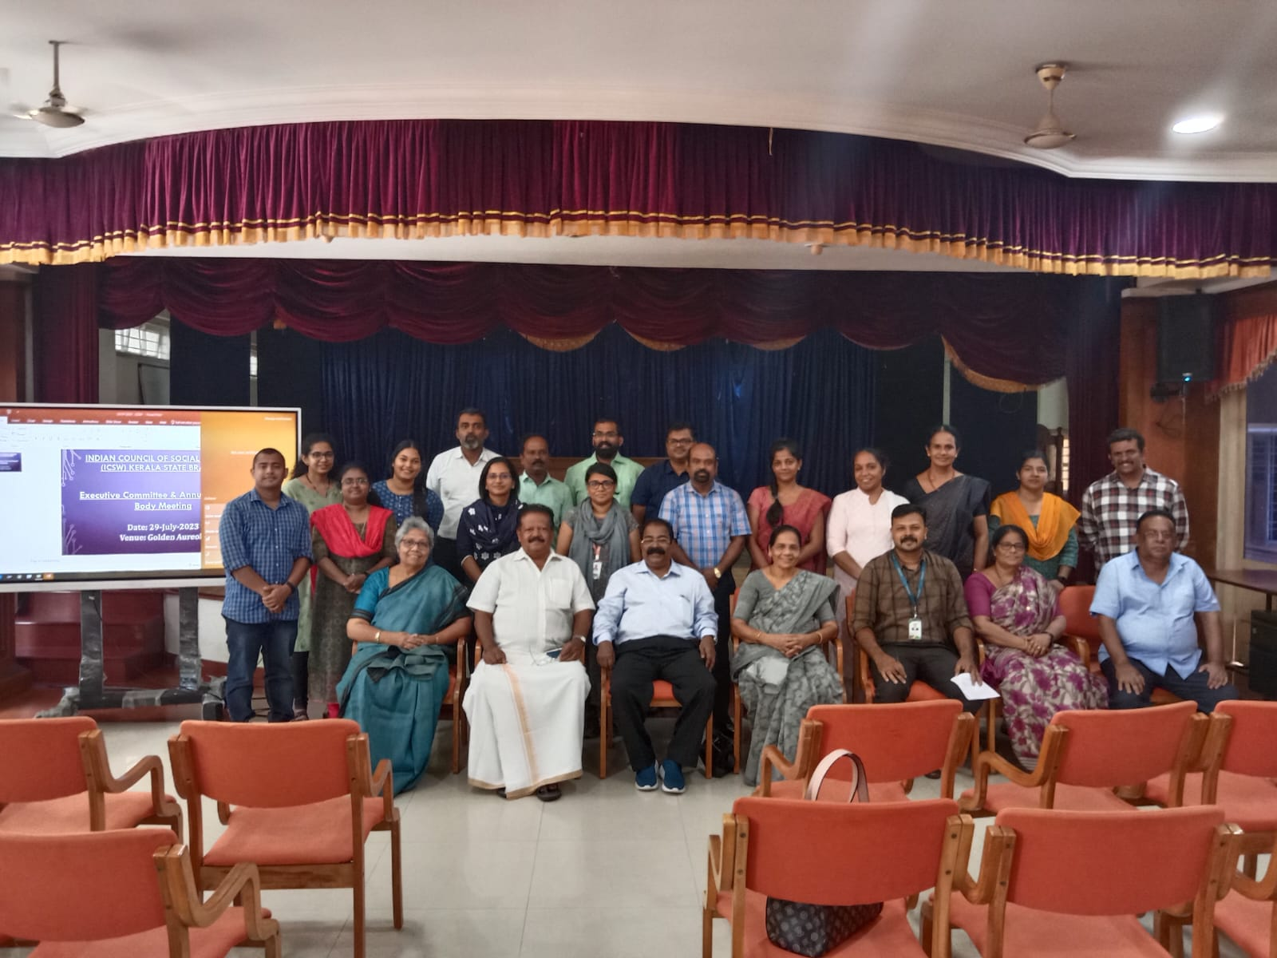
Smt. Rosakutty Abraham, Vice President, ICSW Kerala, conveyed the vote of thanks to all the members. She expressed her happiness that the meeting was live with active discussions and the participation of all the members present. She concluded that the ICSW Kerala should work as equipment for the NGO rather than as an NGO. Also, she pointed out the need for youth participation in the meeting and the ability of ICSW Kerala to support NGOs growth at the State and Central levels. The meeting concluded at 1.30 p.m followed by lunch.

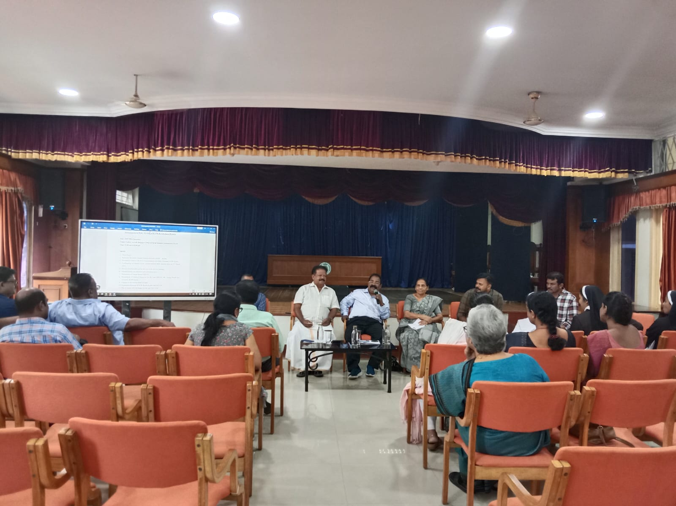

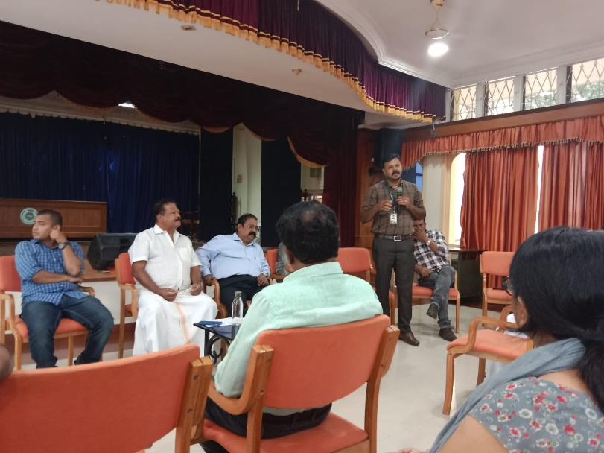

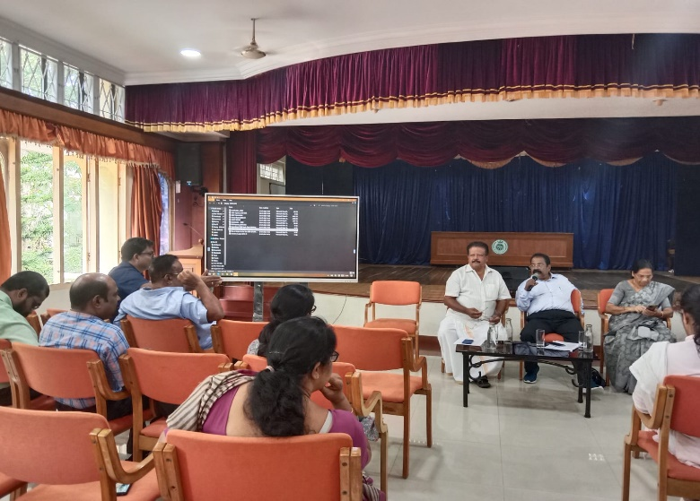

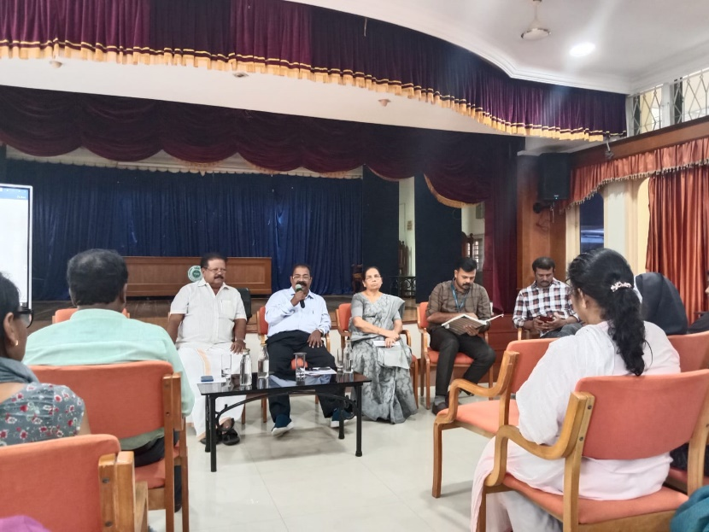

Dr. Kiran Thampi,
General Secretary, ICSW Kerala.

