Indian Council of Social Welfare (ICSW) Kerala State Branch
Executive Committee Meeting (Virtual)

Date: Thursday, 24th November 2022
Time: 5.30 pm to 6.30 pm

Agenda

- Silent Prayer
- Welcome - Mr. Jose Puthukkadan, Vice President, ICSW Kerala (Thrissur branch)
- Presidential Address - Mr. M N Gunavardhanan IAS (Rtd), President, ICSW, Kerala.
- New Project Proposal for ICSW Kerala by Mr. Suresh P, ICSW Thrissur District Chapter President
- Newsletter report by Dr. Kiran Thampi, General Secretary, ICSW Kerala
- Financial Status report by Mr. Anoop Joseph Joy, Treasurer, ICSW Kerala
- Forthcoming AGM at the National level / Discussion
- Invitation by Dr. Mary Venus Joseph, South zone Vice President to participate in seminar
- Felicitations to Dr. Rosakutty State Vice President on her achievement.
- Any other matter
- Vote of Thanks – Mr. Deepak G, Joint Secretary, ICSW Kerala

Members Present
Mr. M N Gunavardhanan IAS (Rtd): President, ICSW Kerala
Smt. Rosakutty Abraham : Vice President, ICSW Kerala (Idukki branch)
Mr. Jose Puthukkadan : Vice President, ICSW Kerala (Thrissur branch)
Dr. Kiran Thampi : General Secretary, ICSW Kerala
Mr. Anoop Joseph Joy : Treasurer, ICSW Kerala
Mr. Deepak G : Joint Secretary, ICSW Kerala
Mr. C V Antony : Executive member
Mr. Aniyan Cheriyan : Immediate past General Secretary, ICSW Kerala
Mr. Suresh : District Chapter representative (Thrissur)
Dr. Mary Venus Joseph : Immediate past President, ICSW Kerala
Mr. Firozkhan : District Chapter representative (Malappuram)
Mr. Ranjith : District Chapter representative (Ernakulam)
Mr .P. K. Johny : District Chapter representative (Kottayam)

Agenda Item 1: Silent Prayer
The meeting commenced after prayer in silence.
Agenda Item 2: Welcome
Mr. Jose Puthukkadan, Vice President, extended a warm welcome to Mr. M N Gunavardhanan IAS (Rtd), honourable President, and to all the EC members. He mentioned the activities carried out in the Thrissur district chapter, such as the World Health Day celebration, Independence Day celebration, medical camp, Onam celebration, membership campaign, etc.
Agenda Item 3: Presidential Address
Mr. M N Gunavardhanan, IAS (Rtd), made the presidential address. Once again, he welcomed all the executive members. He appreciated Dr. Rosakutty, Vice President, ICSW Kerala (Idukki Branch), for her national and international awards and considered the awards to be part of ICSW. He explained the experience in the National Executive Meeting held in Mumbai and says that all the appreciation received by the ICSW Kerala State Branch was only because of the effort of Dr. Mary Venus Joseph. He also introduced the new project proposal for ICSW and welcomed Mr. Suresh P, who would be presenting the proposal in detail.
Agenda Item 4: New Project Proposal for ICSW Kerala
Mr. Suresh P, ICSW Thrissur District Chapter President, explained the project proposal. The objective of the project is to facilitate NGOs at all levels in India and thereby promote ICSW activities. He pointed out the concerns regarding the internal and external challenges in NGO operations, resource support to NGOs, a proposal for networking and support centers for NGOs in all districts of Kerala, effective digital campaign strategies for NGOs in India, digital transformation for NGOs, crowdfunding for non-profit NGOs, a proposal for setting up "networking and support centers for NGOs" or student chapters at colleges, a volunteering and mentoring platform, different vertical committees, and creating a social media presence through Facebook, Youtube, LinkedIn page, and a website. Promote CSSR funding.
Agenda Item 5: ICSW Newsletter report by Dr Kiran Thampi,
Dr. Kiran Thampi, General Secretary, of ICSW Kerala explained the process of the editorial part of the ICSW newsletter. He invited Mr. M N Gunavardhanan IAS (Rtd), to release the first edition of the newsletter. Mr. M N Gunavardhanan IAS (Rtd), release the first edition of the newsletter.
Agenda Item 6: Financial Status report
Mr. Anoop Joseph Joy, Treasurer, ICSW Kerala, states the financial report from April 2022 onwards shows cash in hand of 22,746 and cash in the bank of 63,862. The total amount debited for the various items is Rs. 13260/-.He also explained the status of the registration process.
Agenda Item 7: Forthcoming AGM at the National level / Discussion
Mr. M N Gunavardhanan IAS (Rtd), suggested Dr. May Venus Joseph as the nominee for the impending national General Body Meeting, however she denied his request.
Agenda Item 8: Invitation by Dr. Mary Venus Joseph, South zone Vice President to participate in the seminar
Dr. May venus Joseph invited all the Executive Committee members to the South Zone Meeting held at Chennai on Saturday, December 3, 2022.

Agenda Item 9: Felicitations to Dr. Rosakutty State Vice President on her achievement.
Mr. M N Gunavardhanan IAS (Rtd), stated that we should plan to honour Dr. Rosakuty at the national level meeting.
Agenda Item 10: Any other matter:
- Rosakutty Abraham suggests that, through the ICSW's new project proposal, the supporting and encouraging of NGOs are done. Also, she states that the retention of youth in our country is very important. Practical implementation of the project is also needed.
- May Venus Joseph suggests that this project proposal be presented in the coming Central Executive Committee meeting, and at least 3 days of the workshop should be planned for that. The first level of action for this project should be to start at the district level and create a special committee for functioning by including all the Executive Committee members. She also says that the newsletter should be on the website.
- Aniyan Cheriyan, immediate past General Secretary, ICSW Kerala, appreciates the new office bearers for their valuable contributions.
- Rosakutty Abraham stated that the district chapter had not received the state's 25% of the membership registration fee until now.
- M. N. Gunavardhanan, IAS (Retd), responded to Dr. Rosakutty Abraham, stating that the ICSW will investigate the matter and take appropriate action.
- Kiran Thampi, who proposed the MOU between Rajagiri College of Social Sciences and ICSW, said Mr. M N Gunavardhanan IAS (Rtd), replied that the legal issues behind the MOU wanted to be checked and would be discussed in the next executive committee meeting.
- Rosakutty Abraham expressed her willingness to participate in the national and south zone meetings.
- Deepak G, Joint Secretary, ICSW Kerala, suggested that the registration process for the NGOs and other related matters should be included in each edition of the newsletter.
- M N Gunavardhanan IAS (Rtd), stated that the next executive committee meeting will be planned within one month.
Agenda 11: Vote of thanks
Mr. Deepak G Joint Secretary conveyed the vote of thanks to all the members. He expressed his happiness that the meeting was live with active discussions and appreciated Dr. May Venus Joseph, Suresh P, and Dr. Rosakutty Abraham for their contributions. The meeting came to a close at 6.30. p m.
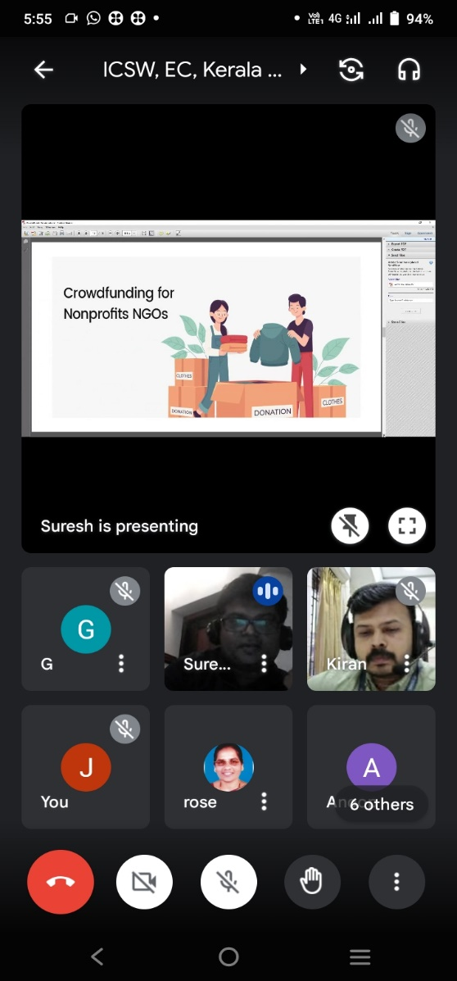
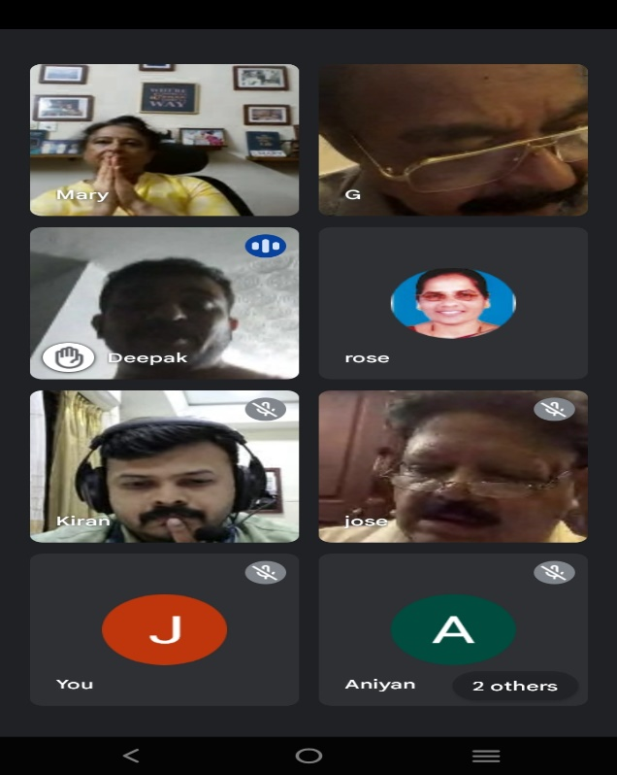

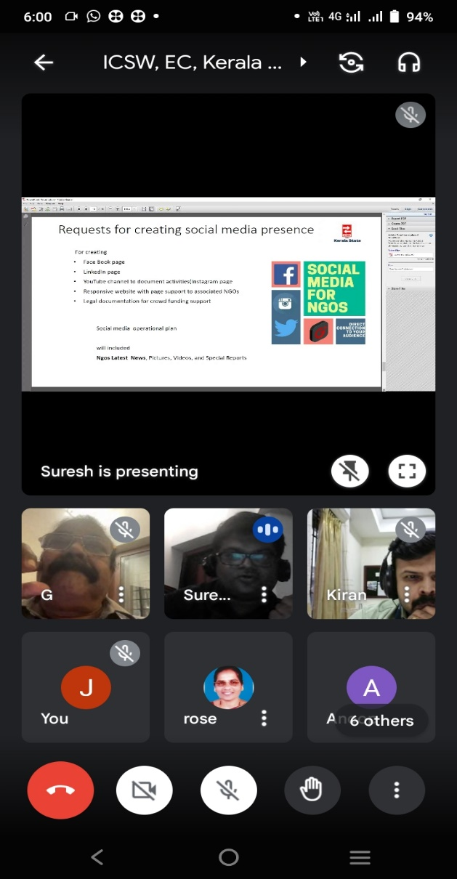

Dr. Kiran Thampi,
General Secretary, ICSW Kerala State Branch.

