ICSW KERALA ANNUAL REPORT 2014-2015

INTRODUCTION

International Council on Social Welfare [ICSW] is a worldwide voluntary sector network in the field of social welfare and policy. ICSW established in 1928 in Paris is a global organization with a long history of service in welfare field. It has National Chapters in more than 75 countries. Indian Chapter of ICSW was started in 1947 at Mumbai and was responsible to lay National Welfare Policies in India and to form a separate Central Ministry of Welfare.

ICSW has been functioning in Kerala since 3rd October 1954. Kerala State branch has its office in the campus of Rajagiri College of Social Sciences, Kalamassery, Ernakulam, with District branches in all the 14 districts of Kerala. ICSW marked its presence in Kerala with:-
Networking of NGO’s
Starting chapters in all the districts
Conducting state and national level seminars on topics related to social work
Undertaking scrutiny work of child adoption.
Social Work Advancement Program

STATE LEVEL EXECUTIVE COMMITTTE FOR THE YEAR 2013-2015

President | : | Mr. M P Antoni, Ernakulam
Vice Presidents | : | Dr. Asha P.Rao,Thrissur
 |  | Fr. Raju George Thottathil
 |  | Mr. Fabian Prince,Thiruvandapuram
 |  | Smt. Rosakutty Abraham
General Secretary | : | Mr. Jineshlal R.V ,Thrissur
Associate Secretary | : | Fr. Jisho Alumkal ,Kottayam
Treasurer | : | Mr. Jacob Thumbayil, Ernakulam

Rep. from all District branches Immediate Past President Immediate Past Gen Secretary
Rep. from Patron Members Rep. from Life Members
Rep. from VO/NGO members

Rep. from Institutional member Rep. from State Branch of Associations of Social Work
Co-opted members

- Elected for the year 2013-15

- Mrs. Beena Sebastian, Ernakulam

- Fr. Saju M.D. CMI,, Ernakulam

- Fr. Jose Alex CMI, Ernakulam

- Dr. Celine Sunny. Ernakulam

- Ms. Aisha Salim. Ernakulam

  - Fr. Romance Antony, Kottayam

- Dr. Anish K.R., ASSK, Ernakulam

- Dr. Mary Joseph, Ernakulam Dr.Cherian.P.Kurien,Idukki

Dr. J. Prasant Palakkapillil CMI, Ernakulam Dr. P. M. Mathew, Kasaragod

Mr. Deepak G, Ernakulam

ICSW KERALA STATE OFFICE MEETINGS

There were seven meetings altogether during the year 2014-2015. They are as follows:
- Working Committee Meeting held on 31st January, 2014 at Rajagiri College of Social Sciences, Kalamasserry.
- Working Committee Meeting held on 02nd January, 2015 at Rajagiri Outreach - Thrissur Office.
- Executive Committee Meeting held on 19th July, 2014 at St. Thomas’ College, Thrissur.
- Executive Committee Meeting held on January 14th, 2015 at Rajagiri College of Social Sciences, Kalamasserry.

- Executive Committee Meeting held on May 16th, 2015 at Rajagiri College of Social Sciences, Kalamasserry.

- Executive Committee Meeting held on February 03rd, 2016 at Rajagiri College of Social Sciences, Kalamasserry.

- Annual General Body Meeting held on September 27th, 2014 at Rajagiri College of Social Sciences, Kalamasserry.

ACTIVITIES

STATE BRANCH AS AN ADOPTION SCRUTINISING AGENCY ICSW

The state branch is the Scrutinizing Agency appointed by the Govt. of India, Supreme Court of India and High Court of Kerala for inter country and in country scrutiny of the petitions filed for adoption/guardianship and to submit its recommendations to the Honorable District Courts and

Family Courts in Kerala for their consideration, while passing orders.

In- country scrutiny cases scrutinized by ICSW

To streamline the procedures for in country adoptions and check possible malpractices, High Court of Kerala approved ICSW Kerala Branch as Scrutiny Agency for in- country adoptions in Kerala in 2004 and got it renewed in 2007 & 2010 for three more years. This year 17 in- country adoption cases were scrutinized.

Details of cases examined:
Name of the Court |  | No of adoptions
1. | District Court | 11
 | Trivandrum
2. | Family Court | 6
 | Palakkad

Visit to Placement Agencies

The Programme Officer regularly visits the Child Placement Agencies to verify documents and to see children for adoption.

Assessment Report

An Assessment report (Austin Jojo - an ISS case from Australia) was prepared by the Program Officer, ICSW-Kerala which was referred by Indian Council of Social Welfare, Central Office, Mumbai.

INTERACTION WITH SOCIAL WORK COLLEGES

As the part of raising membership, ICSW- Kerala organised membership campaigns in different social work colleges all over Kerala. The main aim of this campaign is to bring enthusiastic social work students as the members of ICSW- Kerala. Membership campaigning has been conducted in Social work colleges which include:

- BCM College Kottayam.
- Bharata Mata College Thrikkakara.
- Rajagiri College of Social Sciences, Kalamassery.
- Central University of Kerala, Kasargod.
- Jai Bharath College, Perumbavoor.

MEMBERSHIP

During the year, we had enrolled 159 new members to ICSW- Kerala.

1. | Life members | : 119
2. | NGO members | : 02
3. | Individual members | : 01
4. | Associate members | : 37

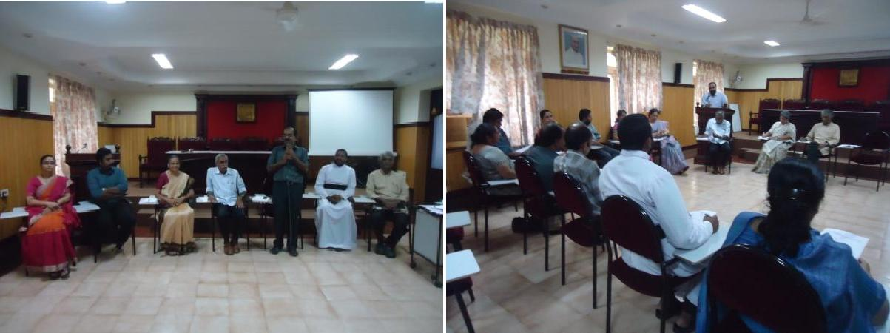
GENERAL BODY MEETING OF ICSW KERALA STATE BRANCH

The General Body meeting of the ICSW Kerala State Branch was held at Rajagiri College of Social Sciences, Kalamassery on Saturday, September 27, 2014.
The meeting started at 02.30 p.m. with a silent prayer. Smt. Rosakutty Abraham, Vice President, ICSW extended a hearty welcome to all the members present. She appreciated all the members for participating in the meeting.
Mr. M P Antoni, in his presidential address congratulated the Treasurer and General Secretary and the elected national team. He said that the General Body meeting will discuss about the success and concerns of ICSWs one year activities. He also mentioned that ICSW could revive the district chapters along with KECRO meetings. He thanked all the Executive Committee members for their support in the functioning of ICSW Kerala. Afterwards, there was a self-introduction session of gathered members. Mr. Shinto Varghese, Secretary, Ernakulam Branch extended the vote of thanks. He thanked Mr. Anoop Joy, the outgoing Programme Officer for the support extended by him. Later Mr. Anoop Joy also thanked everyone else. The meeting ended at 5.00 p.m. which was followed by tea.

Sangamam 2015

Every year NGO Sangamam is being organized by ICSW Kerala State Branch as a get together of voluntary organizations in Kerala since 1998. In the year 2015, NGO Sangamam was organised at Kasargod on 31st January 2015. The theme chosen for Sangamam was Palliative Care – Role of NGOs (Non-Governmental Organisations) and CSOs (Civil Society Organisations). Alpha Palliative Care Trust, a renowned name in palliative care, voluntarily agreed to be a partner in organizing Sangamam at Kasargod. Being a new area of social work and social service, NGO Sangamam aimed at building a relationship with Alpha Pain and Palliative Clinic as to promote similar initiatives and become parties in nation building. Shri M P Antoni, State President, Shri Jineshlal R V, State General Secretary, Shri Jacob Thumpayil, State Treasurer participated in the event along with fifty other participants.

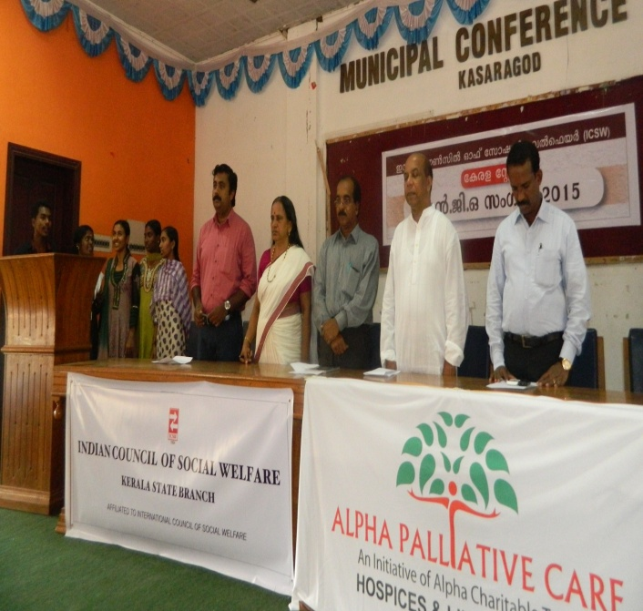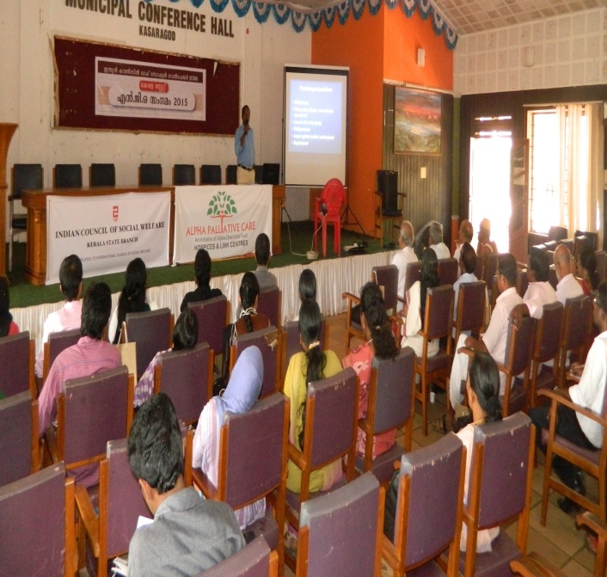
Petition to the Chairman of Kerala State Legal Service Authority, for appointment of social workers while constituting the benches of Lok Adalat.

ICSW Kerala filed a petition to the Chairman of Kerala State Legal Service Authority on October 05, 2015 for appointment of social workers while constituting benches of Lok Adalat. As per Kerala Legal Service Authority Rules 1998, rule no-29, the social worker is a part of the benches of Lok Adalat. Most of the benches of Lok Adalat are not comprised of social workers, though there is a provision for a social worker to be a part of the Lok Adalat Bench. ICSW Kerala requested to the Chairman Kerala State Legal Service Authority to issue necessary orders to all the concerned judicial authorities or Legal Service Committees to appoint social workers in the benches of Lok Adalat. As a result of our efforts, the Kerala State Legal Service Authority approved our request and directed us to forward the list of qualified social workers to the respective District Legal service Authorities of all districts of Kerala and the list of social workers were submitted accordingly.

OTHER ACTIVITIES
Kerala State Branch of ICSW associated in the following activities:
- Participated in “Childline Biennale”, an initiative of Childline Kochi to create awareness regarding Childline among the School children of Ernakulam District.
- Participated in UNCRC @ 25, a UNICEF supported project of Rajagiri Outreach, to identify and congratulate the children who excelled in their lives in spite of their limitations.
- Participated in the “Customer Satisfaction Survey” of mothers using the service of Anganwadis in Ernakulam District, conducted by Rajagiri Research Department and Institute of Management in Government.
- Participated in the Industry Survey conducted by National Council of Applied Economic Research, New Delhi.
- Participated in the Energizing Children for Child Development Plan and Budget 2015, an initiative by Rajagiri Outreach, supported by UNICEF.

PLACEMENT CELL ACTIVITIES

The Placement Cell of ICSW facilitated social workers to improve their skills for career development and assisted them in applying for registration in professional social work regulatory bodies, abroad. ICSW had given professional references to our life members, for registering in professional social work bodies and for securing jobs in countries like Australia, Canada, England, New Zealand and Ireland.

HUMAN DIGNITY WALK ON WORLD SOCIAL WORK DAY
ICSW Kerala State Branch was one of the organizers of the "Human Dignity Walk" a programme conducted as a part of World Social Work Day in Ernakulam, Kerala. It was jointly organised by the different Schools of Social Work, practitioners and the academicians in Kerala. ICSW Kerala State Branch was also a part of the programme. The programme included a Walkathon from Ernakulam Marine Drive to Ashir Bhavan, Kacherippady, a Street Play at Marine Drive and later the concluding ceremony at Ashir Bhavan. The programme was organised on March 17th, 2015. Mrs. Mary Venus Joseph (National and State Executive Member), Fr. Prasant Palakkappillil (National Associate Secretary and State Executive Member), and Mr. Jacob Thumpayil (State Treasurer) took part in the program.
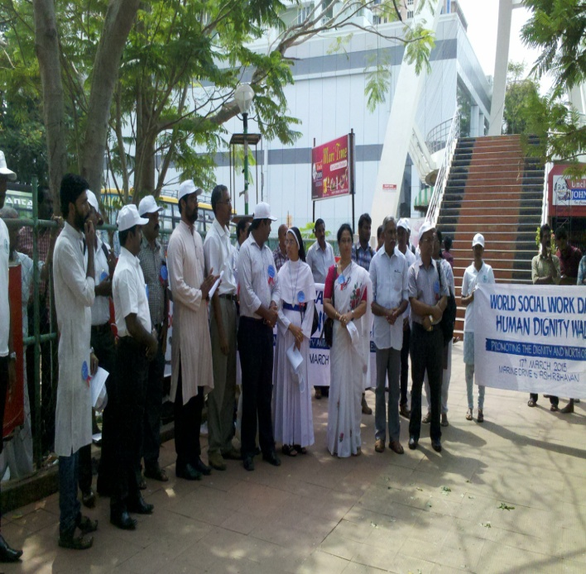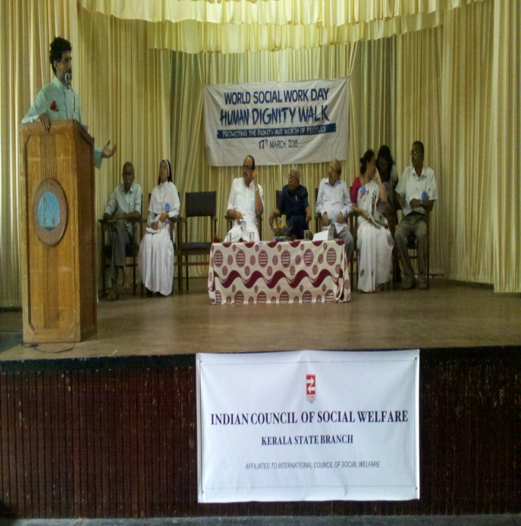

LIVE LAB

ICSW as a Live- lab of Rajagiri College of social Sciences continued to facilitate social work students for undertaking organizational study on child welfare and adoption, networking among

NGO’s etc.

CONCLUSION

ICSW Kerala, during 62 years of its’ existence, is glad that we, as an umbrella body of networking, is gaining strength. The present team gratefully acknowledges the support of the National Team, the various district branches of the state, each of the institutional and individual members, Rajagiri College of Social Sciences, Department of Social Welfare, Kerala, Central Adoption Resource Authority (CARA), High Courts, District Courts & all Family courts in Kerala, all Child Welfare Committees, Association of Schools of Social Work in Kerala (ASSK) and Live Labs in Rajagiri who were abundantly helpful and offered their priceless support. We look forward to continue the great tasks with your enormous and high-quality support.

