Revival meeting of Ernakulam Chapter
Revival meeting of Ernakulam Chapter was held at Santhwana Counselling and Psychotherapy Centre near Sudheendra Hospital, Chittoor road Kacheripady from 4 pm on Saturday, 24th August 2019.
A meeting of Ernakulam District was held on 26th August 2019 at St Alberts College, Ernakulam at 4.30 PM. The following office bearers were elected for the year 2019-20. Adv Rajendran Nair presided the election.
President: - Fr. Jolly John
Vice President: - Anitta Francis
Gen. Secretary: -Adv. Sebin Thomas
Associate Secretary; - Shinto Varghese
Treasurer: - Anoop Joseph Joy
Seven more executive members too were elected to the Ernakulam District-
Jojo Mathew, Laiju John, Biju K Isaac, Renjith KU,Adv Teena Cheriyan, Adv Shaijan Joseph and Jacob Jose.

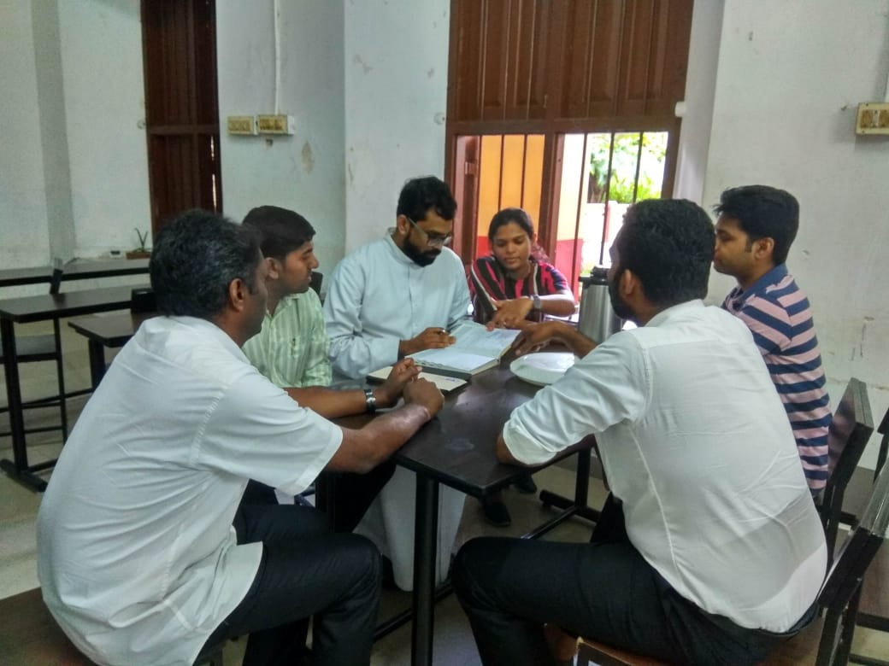

Major decisions taken
To assist the state chapter in organizing the programme of ICSW Kerala’s 65th anniversary in Oct 2019
To assist in identifying organisations for Valavi Award 2019
To assist in finding sponsorship for the programme of ICSW Kerala’s 65th anniversary in Oct 2019
To send onam greeting’s letter to Ernakulam District life members and NGOs in Ernakulam
TO organize a Ernakulam District programme for NGOs (this year end). To create a talent pool for ICSW Ernakulam District
To strengthen the ICSW Kerala membership drive.
To create a mail id for Ernakulam District ,start a bank ac, letter pad and seal

